Bad Design
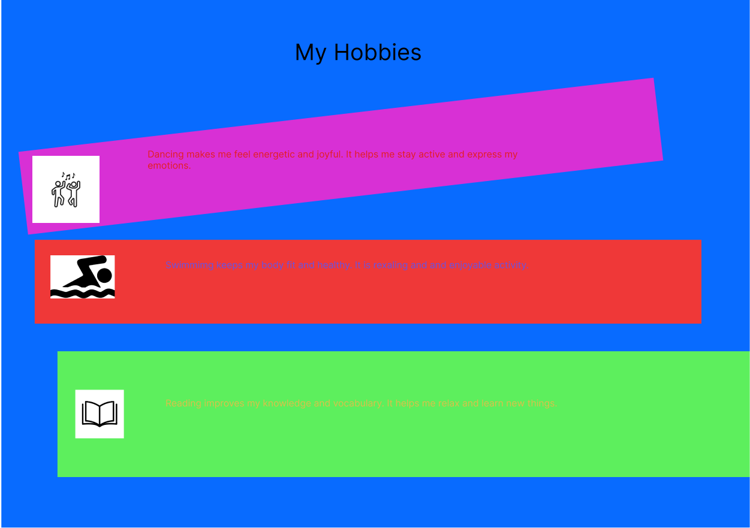

1. Form Over Function
This is the classic "looks pretty, works terribly" trap. If a chair is a masterpiece of modern art but gives you a backache in ten minutes, it’s a failure of design. Design isn't just art; it's a solution to a problem.
2. Lack of "Affordance"
In design, an affordance is a visual clue to how something should be used.
- Good Design: A flat plate on a door tells you to "Push."
- Bad Design: A vertical handle on a door that you're supposed to push (often called a "Norman Door").
3. High Cognitive Load
If a user has to stop and think—or worse, read a manual—to perform a basic task, the design is too complex. Good design feels intuitive, almost like it's anticipating your next move.
4. Accessibility Failures
If a design only works for people with perfect 20/20 vision, full mobility, or right-handedness, it’s exclusionary.
- Example: Low-contrast text (light gray on white) might look "sleek," but it's unreadable for many.
Good Design
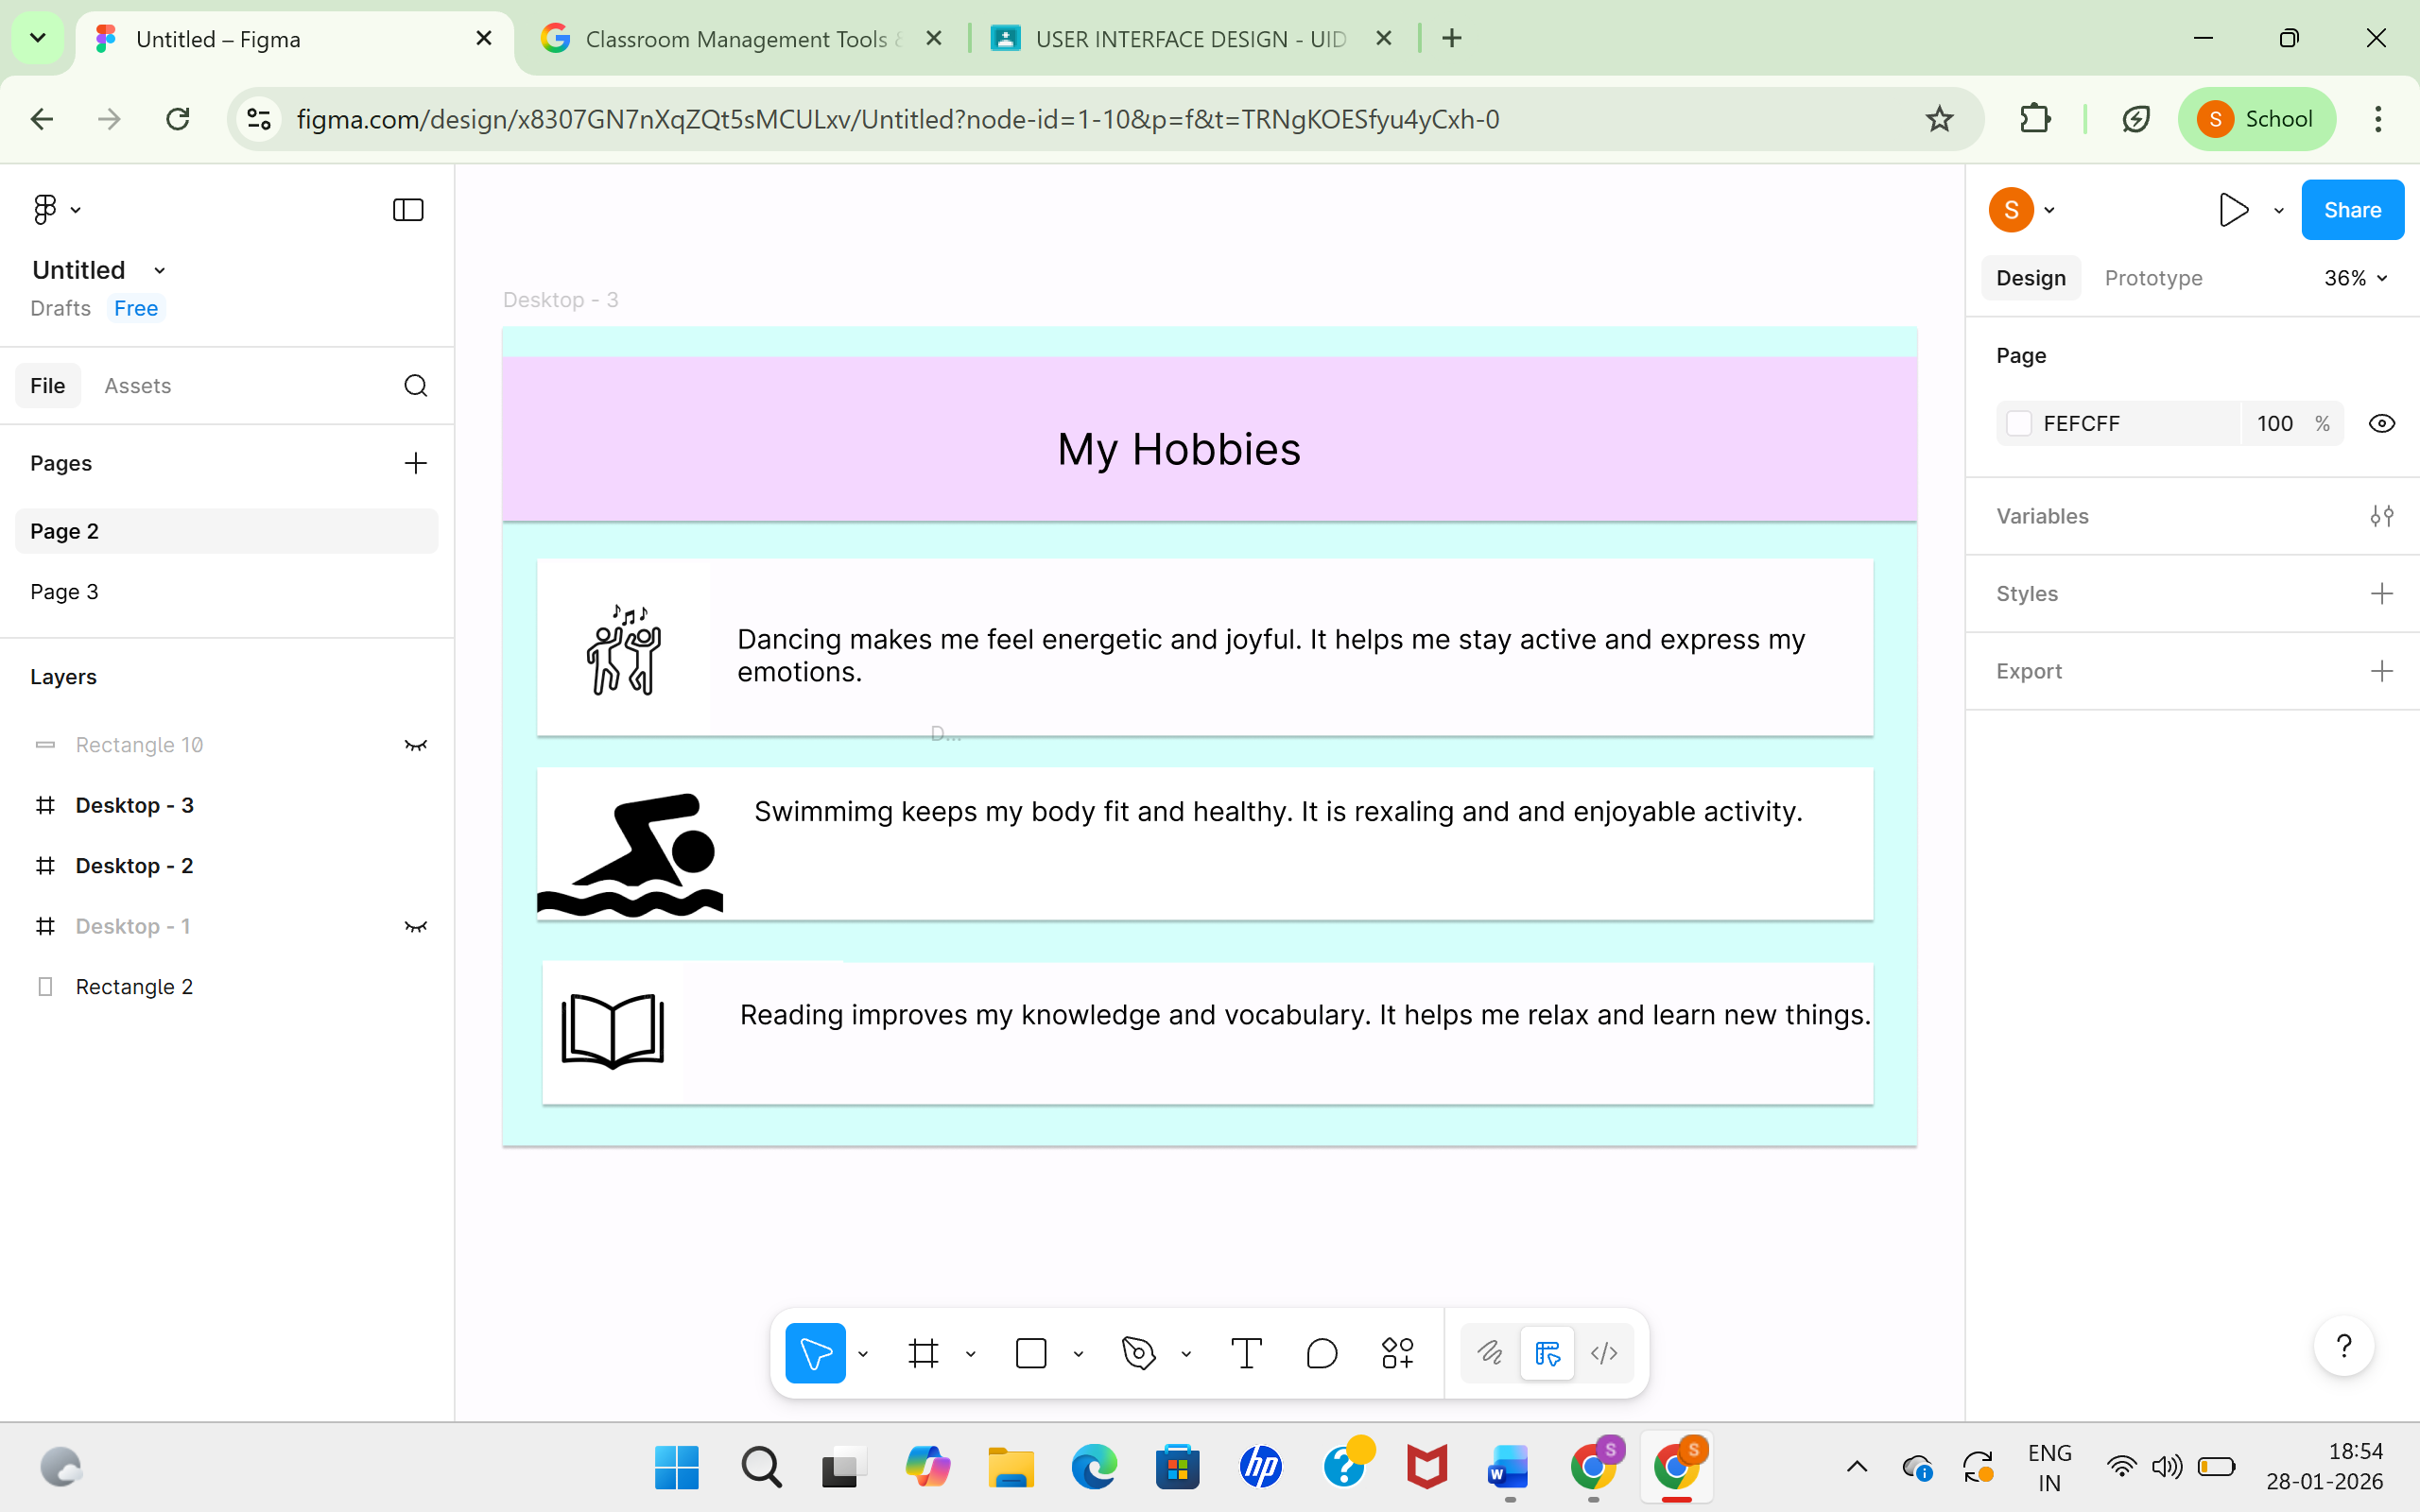
1. It’s "Intuitive" (The Don Norman Rule)
You shouldn't need a manual to use it. Good design uses mappings that make sense—like a volume knob that turns clockwise to increase sound or a trash can icon that clearly means "delete." It meets the user's mental model of how the world works.
2. Form Follows Function
In great design, the aesthetic isn't just "paint" applied at the end; the beauty comes from how well the object works.
- Example: The original iPod click wheel wasn't just a style choice; it was the most efficient way to scroll through 1,000 songs with one thumb.
3. It Solves a Real Problem
Bad design adds features for the sake of "innovation." Good design removes friction. If a product makes a task faster, easier, or more enjoyable without adding unnecessary steps, it’s a winner.
4. Accessibility and Inclusivity
Good design considers the widest possible range of users.
- The "Curb Cut" Effect: Sloped curbs were designed for wheelchairs, but they also help people with strollers, suitcases, and bicycles. When you design for the margins, you usually make a better product for everyone.

